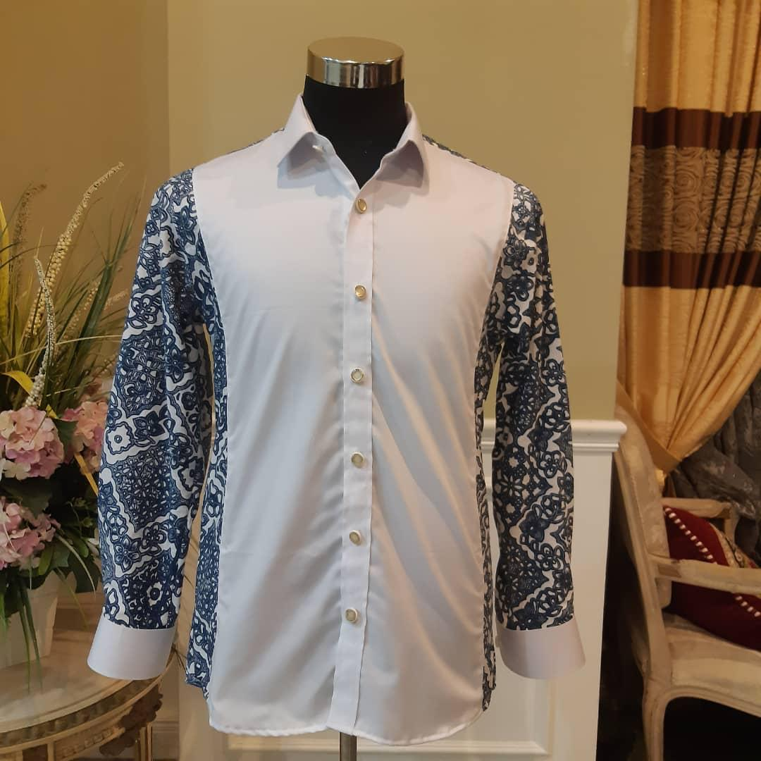 | (MAN 1) LONG-SLEEVE SHIRT  - Original Terengganu batik made of cotton, blended with Japanese Cotton and Germany cotton.  - Uniquely designed by our designer - custom made.  - Only one batik design for every customer - no duplications.  - Sizes up to 10XL.  - We also accept multiple orders with the same batik design but with different colours/patterns. (NOTE : SAME PRICE FOR S - XL. DIFFERENT PRICE BEYOND XL)  - Delivery within two weeks. Delivery charge is excluded.  - Deposit as low as 50% for each placed order.  - Highly suggested to use dry-cleaning.  RM250  Size : M (slim fit)
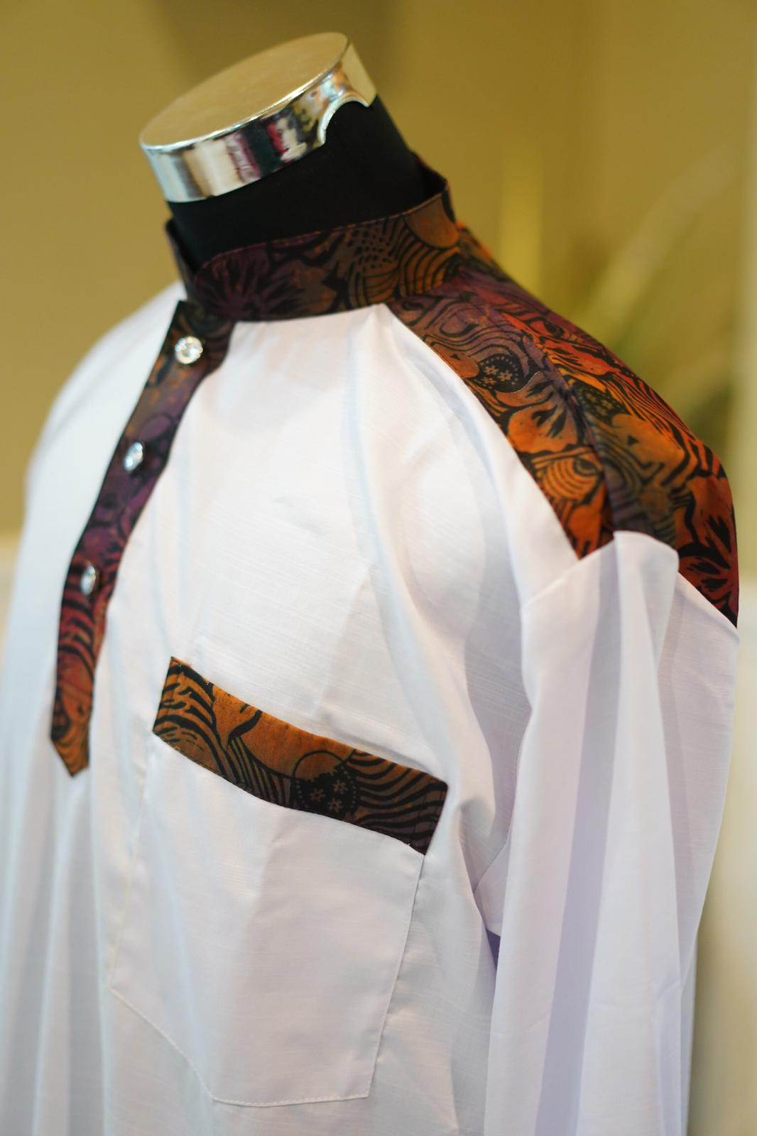 | (MAN 2) JUBAH - SOLD  - Original Terengganu batik made of cotton blended with Japanese cotton and European cotton.  - Uniquely designed by our designer - custom made.  - Only one batik design for every customer - no duplications.  - Sizes up to 10XL.  - We also accept multiple orders with the same batik design but with different colours/patterns.  - Delivery within two weeks. Delivery charge is excluded.  - Deposit as low as 50% for each placed order.  - Highly suggested to use dry-cleaning.  RM250  Size : L
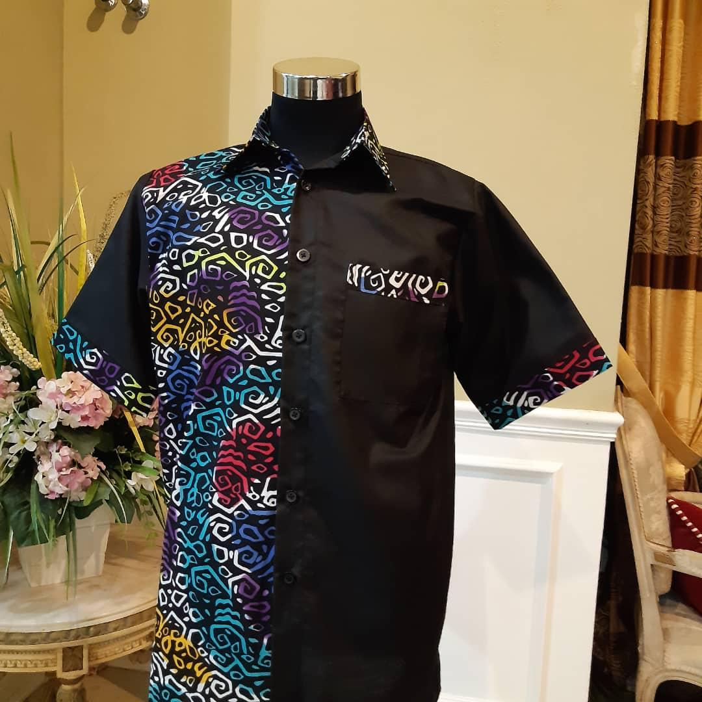 | (MAN 3) SHORT-SLEEVE SHIRT - SOLD  - Original Terengganu batik made of cotton, blended with Japanese Cotton and European/Germany/Swiss cotton.  - Uniquely designed by our designer - custom made.  - Only one batik design for every customer - no duplications.  - Sizes up to 10XL.  - We also accept multiple orders with the same batik design but with different colours/patterns.  - Delivery within two weeks. Delivery charge is excluded.  - Deposit as low as 50% for each placed order.  - Highly suggested to use dry-cleaning.  RM250  Size : Regular
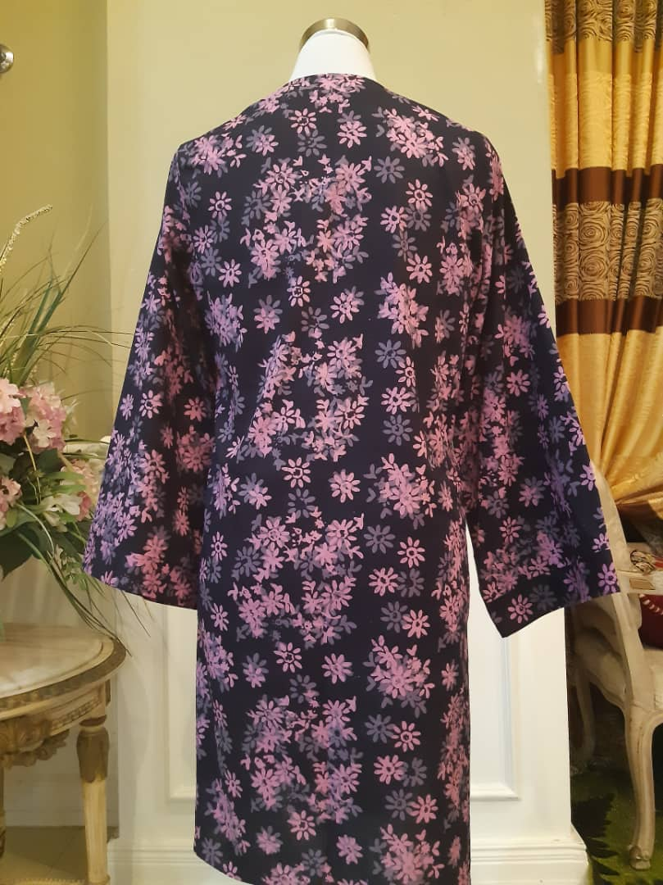  change to front view | (WOMAN 1) CARDIGAN  - Original Terengganu batik made of cotton blended with Japanese cotton.  - Uniquely designed by our designer - custom made.  - Only one batik design for every customer - no duplications.  - Sizes up to 10XL.  - We also accept multiple orders with the same batik design.  - Delivery within two weeks. Delivery charge is excluded.  - Deposit as low as 50% for each placed order.  - Highly suggested to use dry-cleaning.  RM200  Size : M
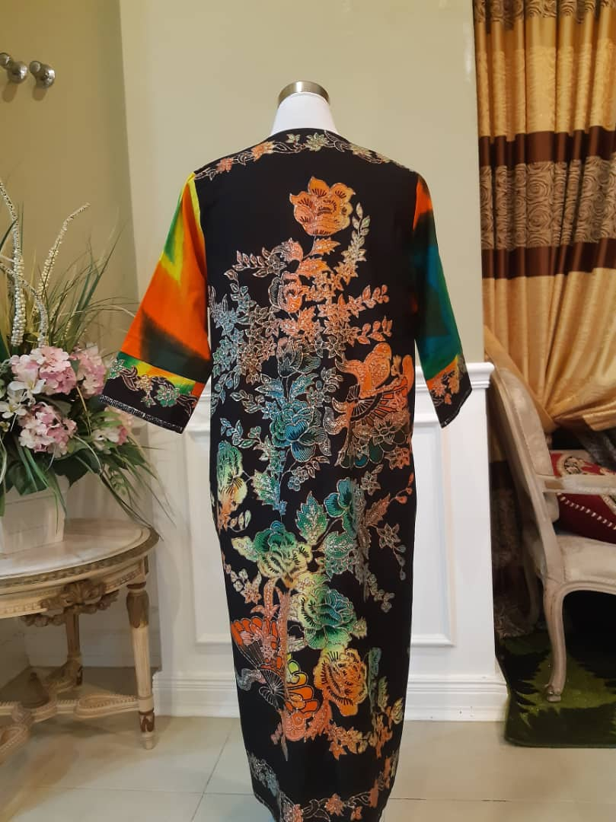  change to front view | (WOMAN 2) CARDIGAN  - Original Terengganu batik made of cotton blended with Japanese cotton.  - Uniquely designed by our designer - custom made.  - Only one batik design for every customer - no duplications.  - Sizes up to 10XL.  - We also accept multiple orders with the same batik design.  - Delivery within two weeks. Delivery charge is excluded.  - Deposit as low as 50% for each placed order.  - Highly suggested to use dry-cleaning.  RM200  Size : M
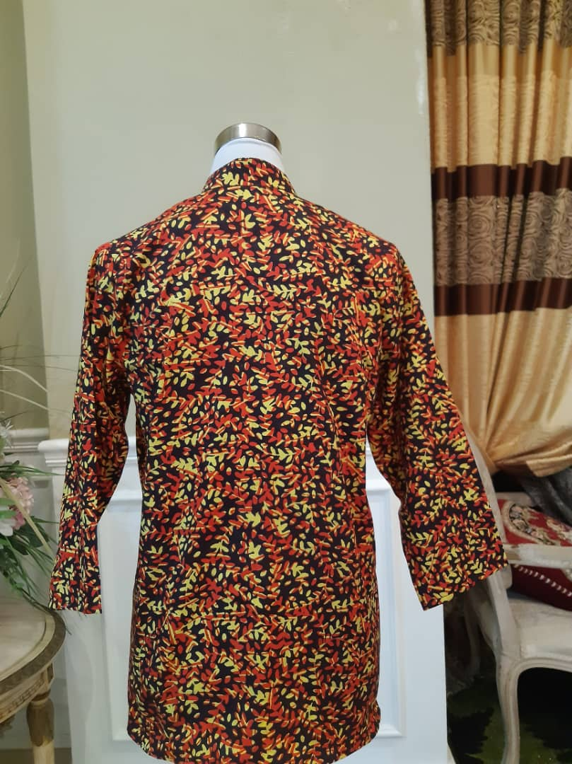  change to front view | (WOMAN 3) CARDIGAN  - Original Terengganu batik made of cotton blended with Japanese cotton.  - Uniquely designed by our designer - custom made.  - Only one batik design for every customer - no duplications.  - Sizes up to 10XL.  - We also accept multiple orders with the same batik design.  - Delivery within two weeks. Delivery charge is excluded.  - Deposit as low as 50% for each placed order.  - Highly suggested to use dry-cleaning.  RM200  Size : S
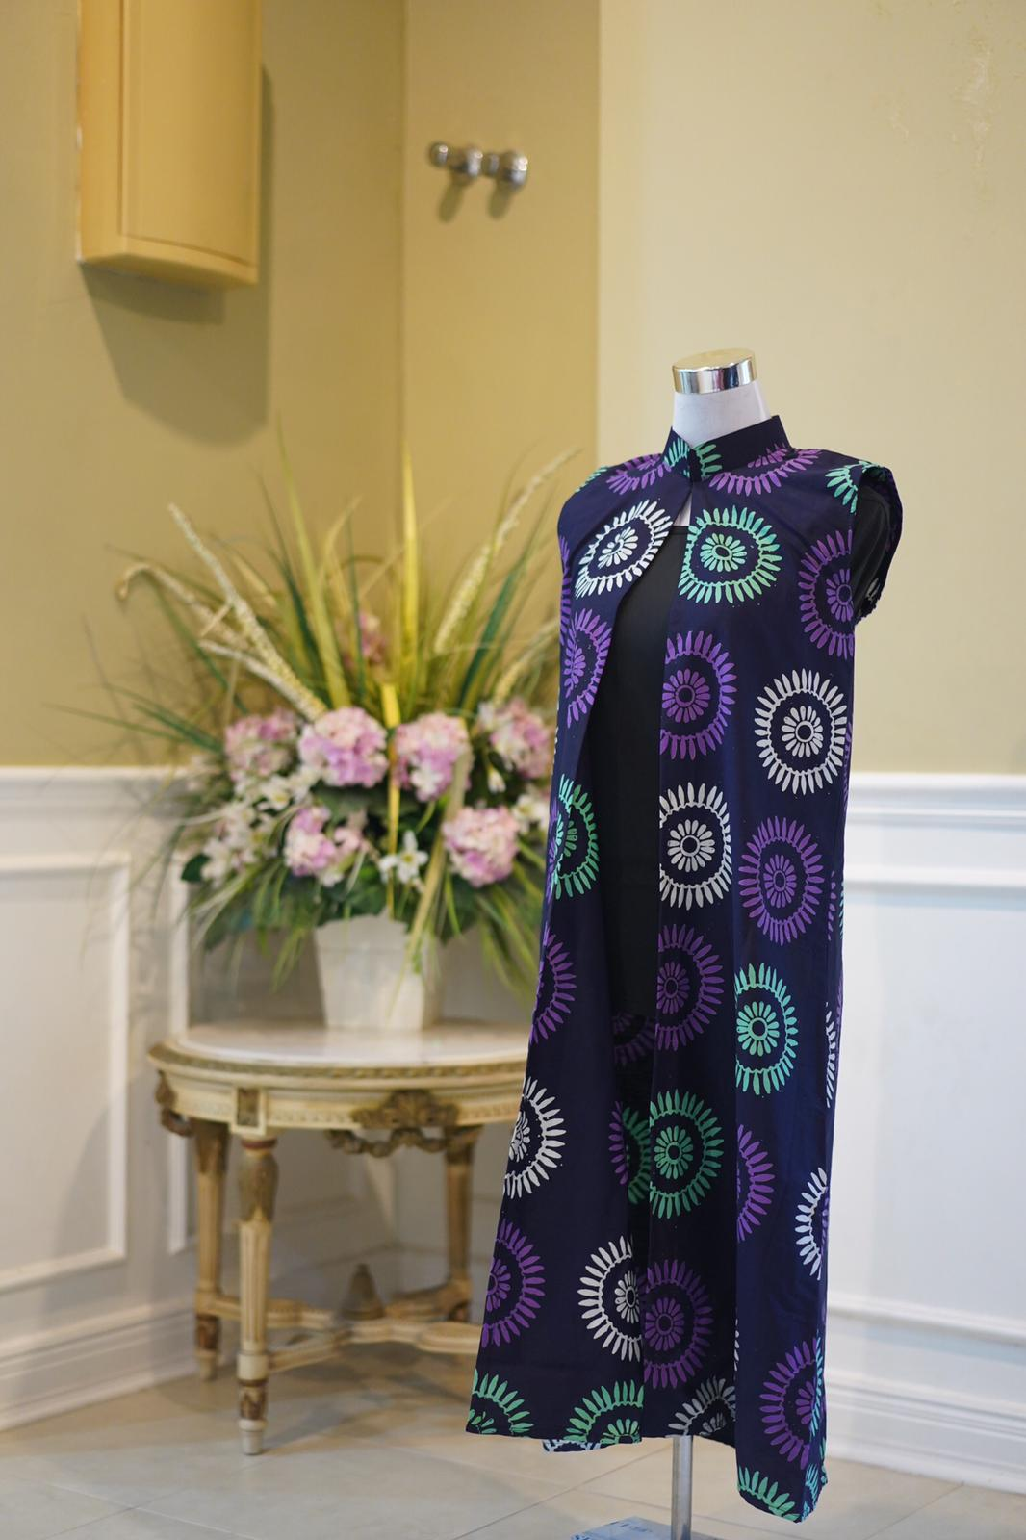 | (WOMAN 4) CARDIGAN  - Original Terengganu batik made of cotton blended with Japanese cotton.  - Uniquely designed by our designer - custom made.  - Only one batik design for every customer - no duplications.  - Sizes up to 10XL.  - We also accept multiple orders with the same batik design.  - Delivery within two weeks. Delivery charge is excluded.  - Deposit as low as 50% for each placed order.  - Highly suggested to use dry-cleaning.  RM200  Size : S
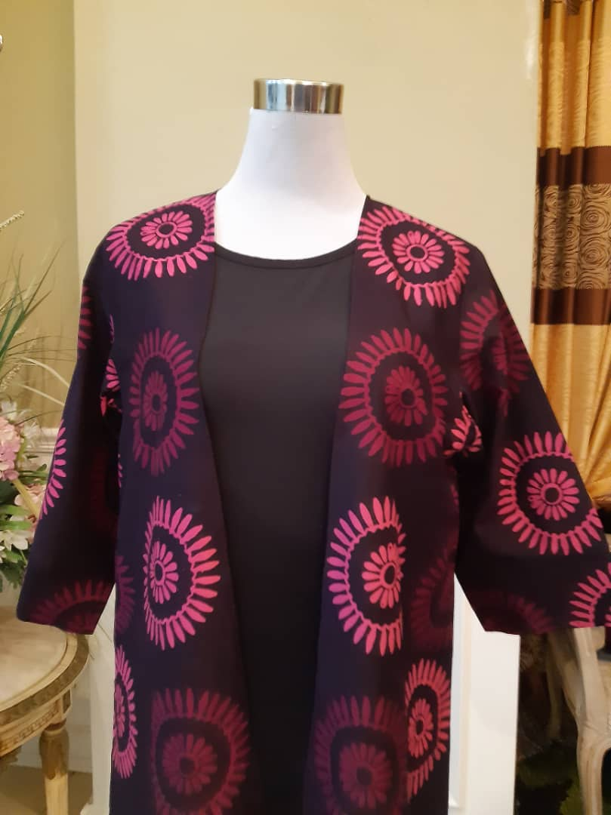 | (WOMAN 5) CARDIGAN  - Original Terengganu batik made of cotton blended with Japanese cotton.  - Uniquely designed by our designer - custom made.  - Only one batik design for every customer - no duplications.  - Sizes up to 10XL.  - We also accept multiple orders with the same batik design.  - Delivery within two weeks. Delivery charge is excluded.  - Deposit as low as 50% for each placed order.  - Highly suggested to use dry-cleaning.  RM200  Size : L
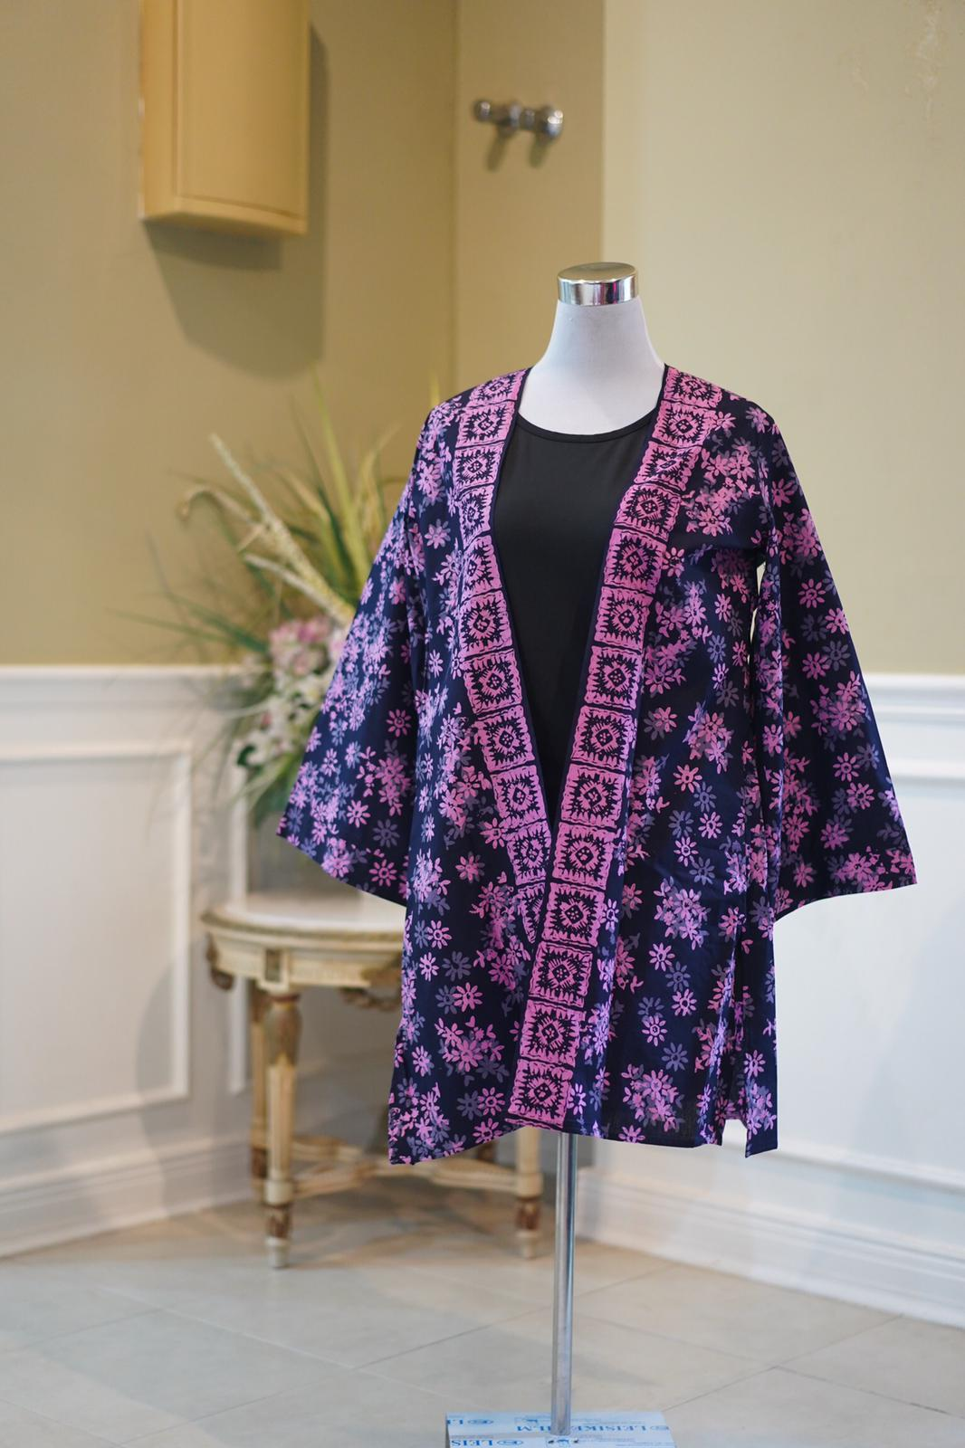 | (WOMAN 6) CARDIGAN  - Original Terengganu batik made of cotton blended with Japanese cotton.  - Uniquely designed by our designer - custom made.  - Only one batik design for every customer - no duplications.  - Sizes up to 10XL.  - We also accept multiple orders with the same batik design.  - Delivery within two weeks. Delivery charge is excluded.  - Deposit as low as 50% for each placed order.  - Highly suggested to use dry-cleaning.  RM200  Size : M
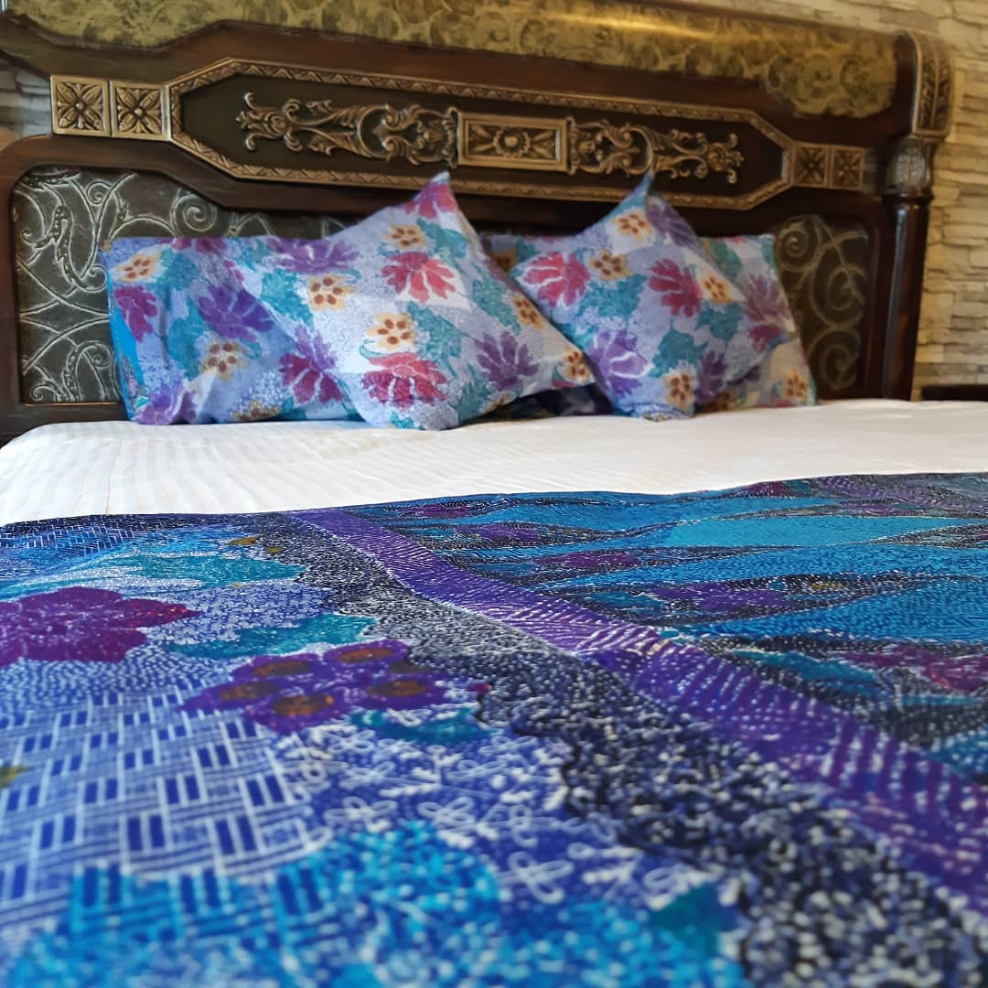 | BEDSHEET 1 - SOLD OUT  - Original Terengganu batik made of cotton blended with Japanese cotton.  - Uniquely designed by our designer.  - Only one batik design for every customer.  - Each set comes with 2 units of pillow cover, 2 units of cushion cover, 1 runner and 1 white bedsheet made using high quality materials used by 5-star hotels. Its runner is sewn with unique batik design.  - Delivery within two weeks. Delivery charge is excluded.  - Deposit as low as 50% for each placed order.  - Highly suggested to use dry-cleaning.  RM300  Size : KING
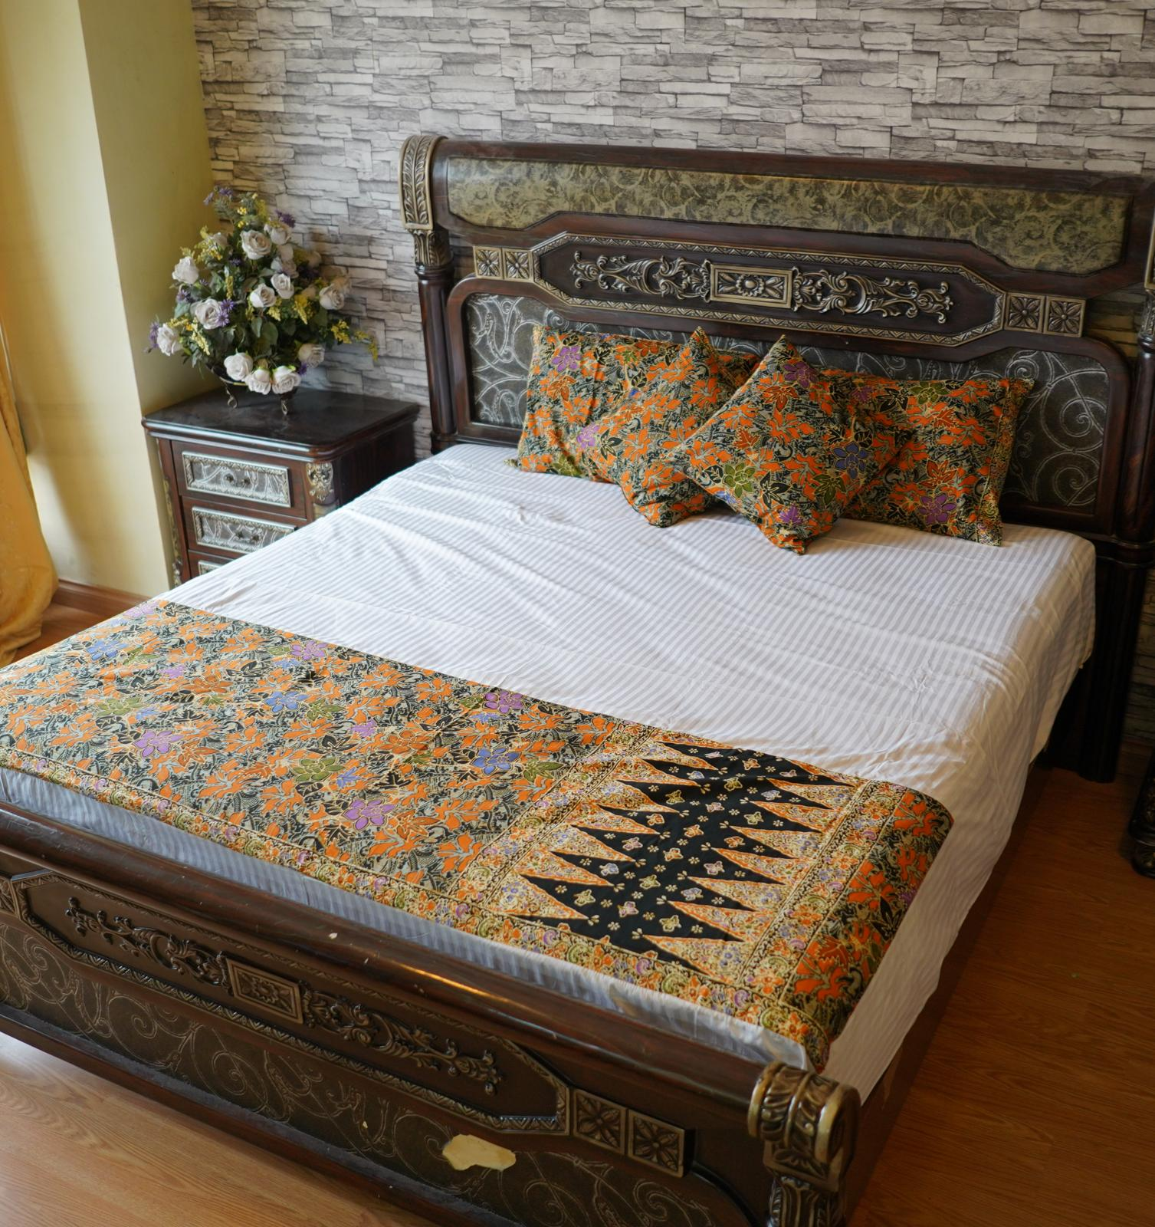 | BEDSHEET 2  - Original Terengganu batik made of cotton blended with Japanese cotton.  - Uniquely designed by our designer.  - Only one batik design for every customer.  - Each set comes with 2 units of pillow cover, 2 units of cushion cover, 1 runner and 1 white bedsheet made using high quality materials used by 5-star hotels. Its runner is sewn with unique batik design.  - Delivery within two weeks. Delivery charge is excluded.  - Deposit as low as 50% for each placed order.  RM300  Size : KING
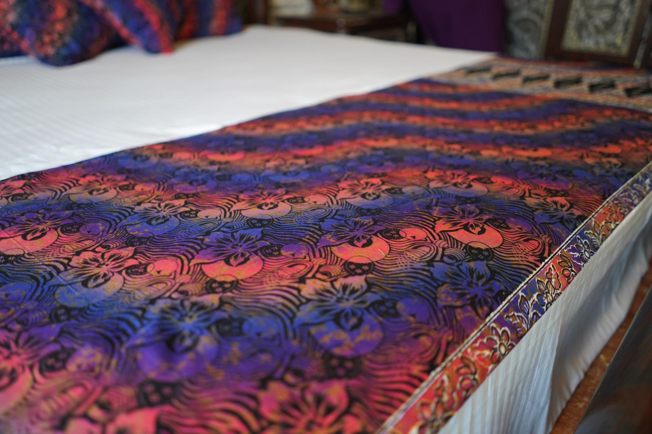 | BEDSHEET 3 - SOLD OUT  - Original Terengganu batik made of cotton blended with Japanese cotton.  - Uniquely designed by our designer.  - Only one batik design for every customer.  - Each set comes with 2 units of pillow cover, 2 units of cushion cover, 1 runner and 1 white bedsheet made using high quality materials used by 5-star hotels. Its runner is sewn with unique batik design.  - Delivery within two weeks. Delivery charge is excluded.  - Deposit as low as 50% for each placed order.  - Highly suggested to use dry-cleaning.  RM300  Size : KING
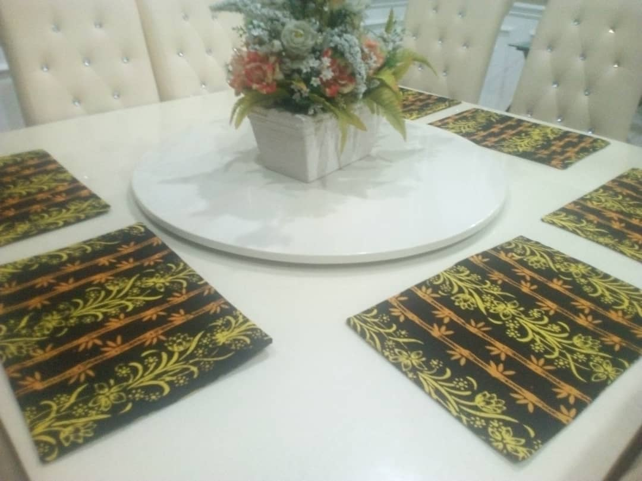 | PLACE MAT 1 - SOLD OUT  - Original Terengganu batik made of cotton blended with Japanese cotton.  - Uniquely designed by our designer - custom made.  - Each set contains 6 units of placemats.  - Only one batik design for every customer.  - Custom-made design request available for orders exceeding 6 units for each set.  - Delivery within two weeks. Delivery charge is excluded.  - Deposit as low as 50% for each placed order.  - Highly suggested to use dry-cleaning.  RM100
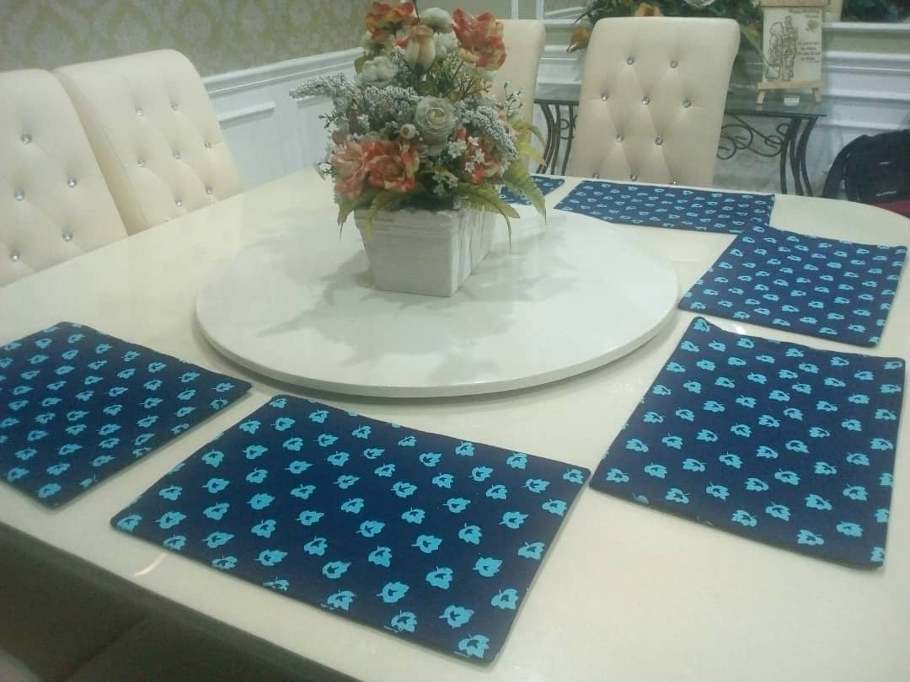 | PLACE MAT 2 - SOLD OUT  - Original Terengganu batik made of cotton blended with Japanese cotton.  - Uniquely designed by our designer - custom made.  - Each set contains 6 units of placemats.  - Only one batik design for every customer.  - Custom-made design request available for orders exceeding 6 units for each set.  - Delivery within two weeks. Delivery charge is excluded.  - Deposit as low as 50% for each placed order.  - Highly suggested to use dry-cleaning.  RM100
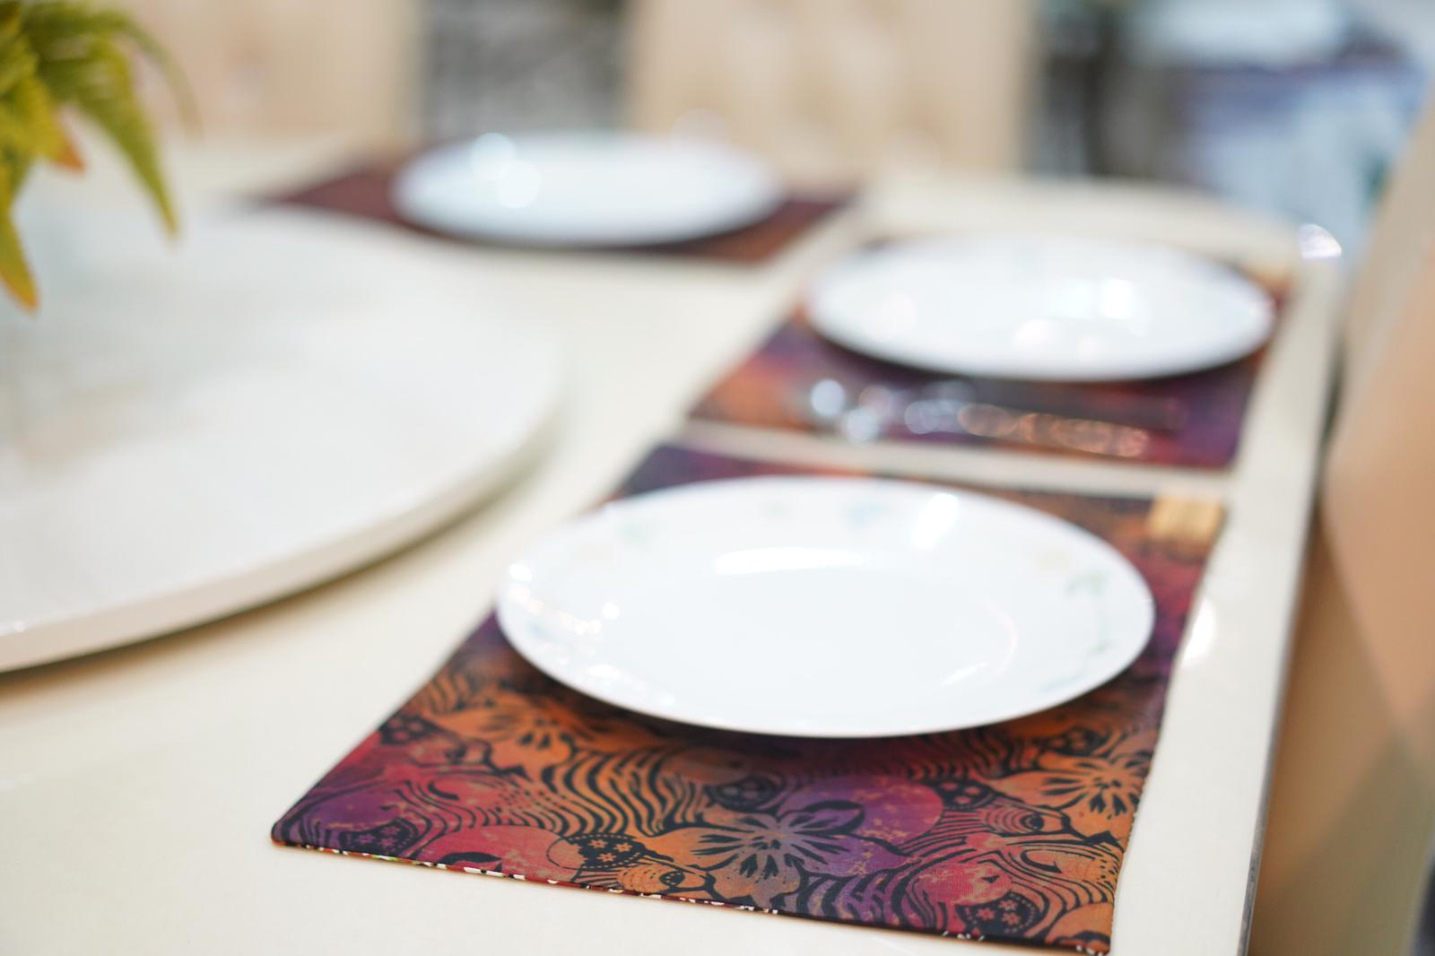 | PLACE MAT 3  - Original Terengganu batik made of cotton blended with Japanese cotton.  - Uniquely designed by our designer - custom made.  - Each set contains 6 units of placemats.  - Only one batik design for every customer.  - Custom-made design request available for orders exceeding 6 units for each set.  - Delivery within two weeks. Delivery charge is excluded.  - Deposit as low as 50% for each placed order.  - Highly suggested to use dry-cleaning.  RM100
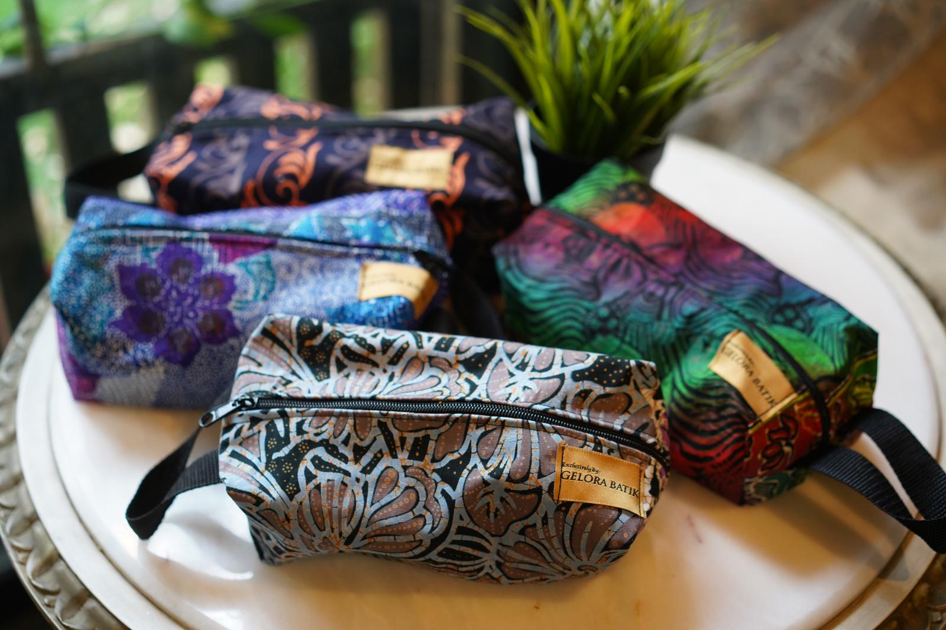 | MULTIPURPOSE BOX  - Original Terengganu batik made of cotton - internal skin made of European/Germanic cotton.  - Uniquely designed by our designer - custom made.  - Can be utilized as stationery case, make-up case, medicine box and others.  - Dimension : 15 inch x 12 inch.  - Delivery within two weeks. Delivery charge is excluded.  - Deposit as low as 50% for each placed order.  RM35
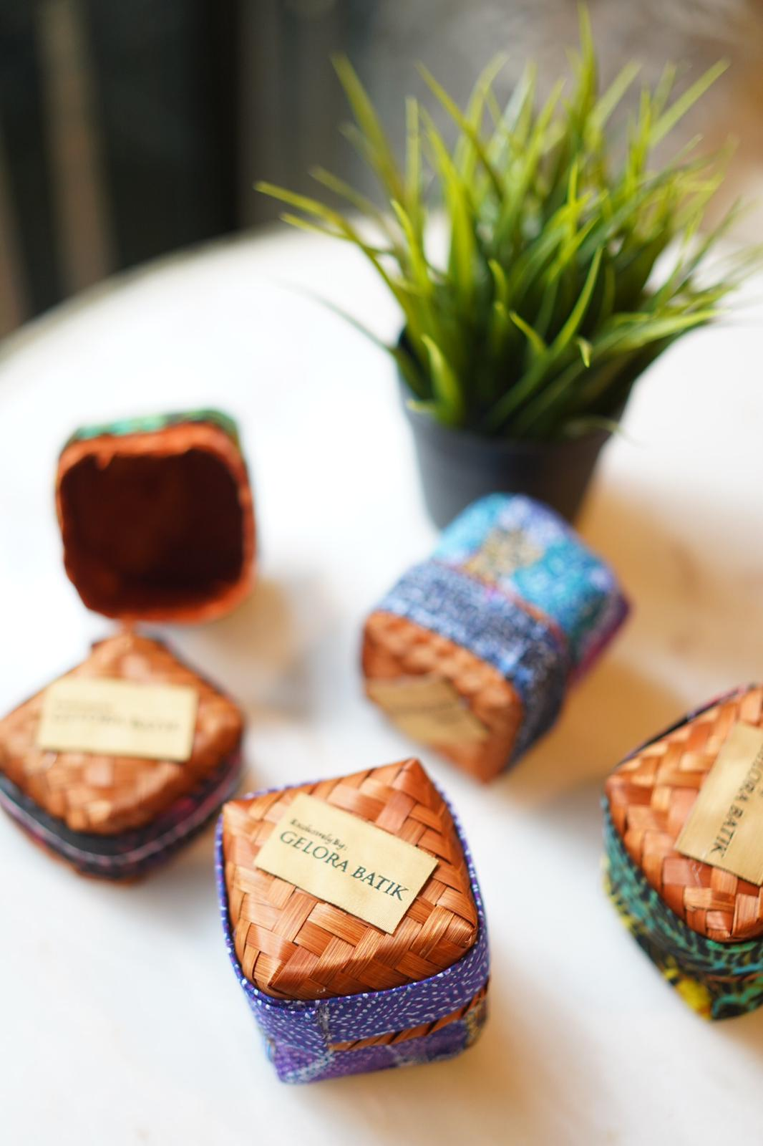 | RATTAN BOX  - Made of rattan weaved and decorated with Original Terengganu batik made of cotton.  - Can be utilized to keep accessories, events and others.  RM20

